NAME: K.Dhana sri ROLL.NO:2303a52153 BATCH:41 ASSIGNMENT 4.4
TASK1: ZERO SHOT PROMPT:
generate a code that analyxe customer review on an ecommerce website and classify them as positive, negative or neutral sentment create 10 reviews inside the code itself and print the classification result for each review.
Code;
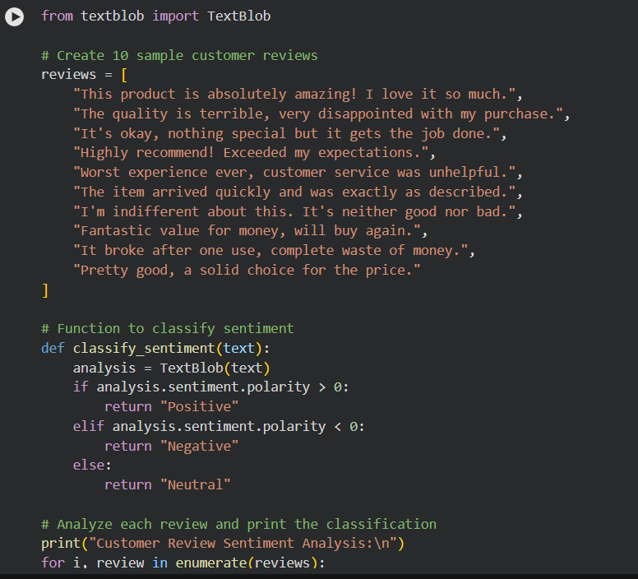
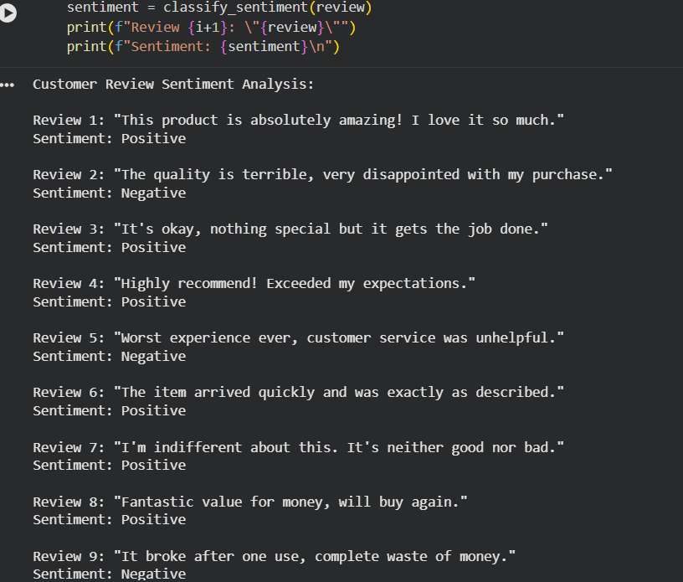
ONE- SHOT: classify the reviews mapped to sentiments Review: I absolutely love this product! It has changed my life for the better.
Sentiment:
Positive. now generate python code to display the output for all reviews in the same format as above.i want data in code itself not in output.
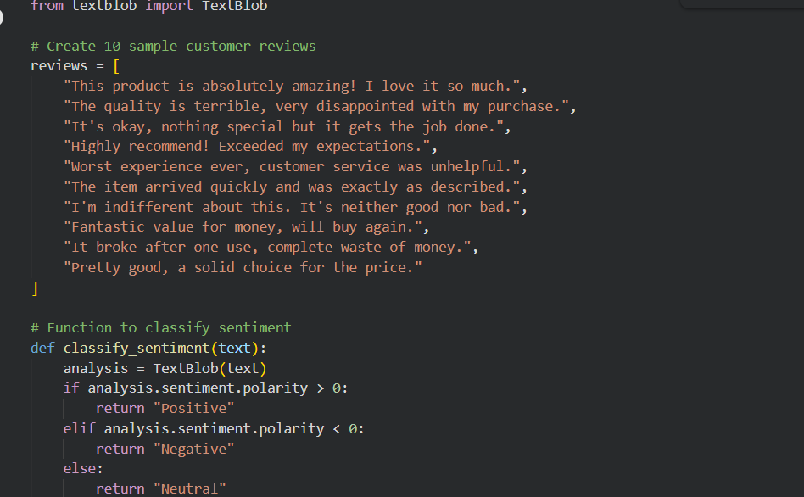
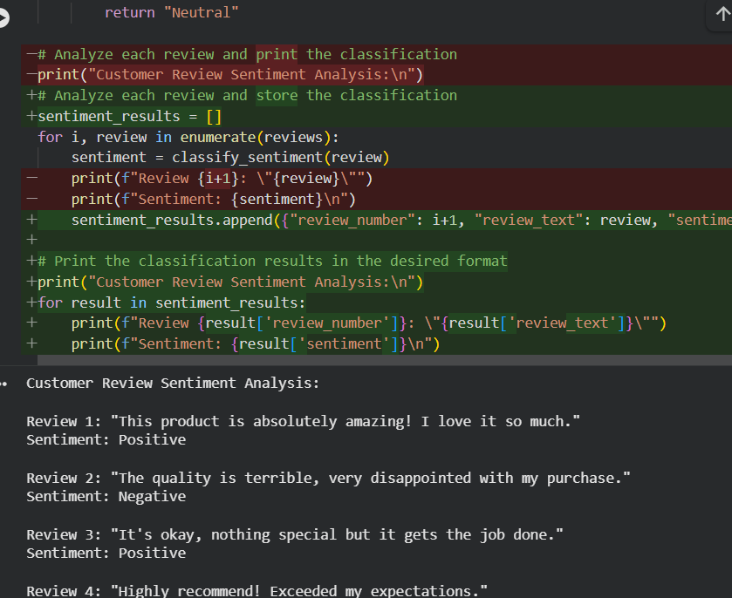
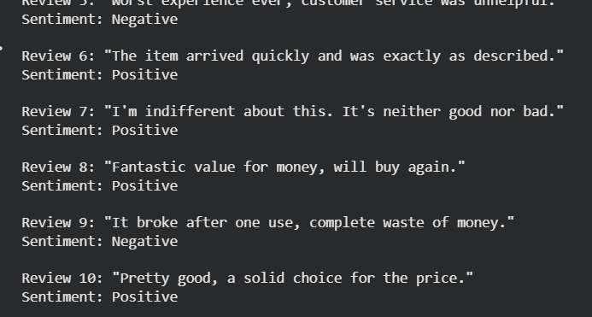
TASK2: ONE SHOT PROMPT: Prioritzing the incoming emails. Example: The production server is not responding. fix ASAP .
Priority: High. Now generate python code to classify email priority into high, medium and low based on certain keywords. Create 10 email samples inside the code itself and print the classification result for each email.
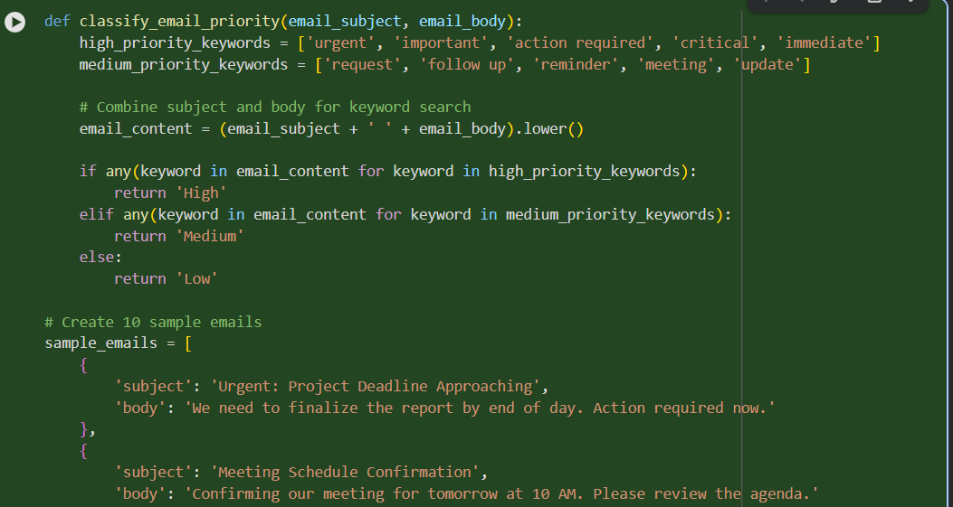
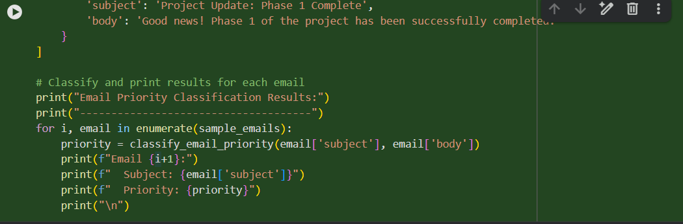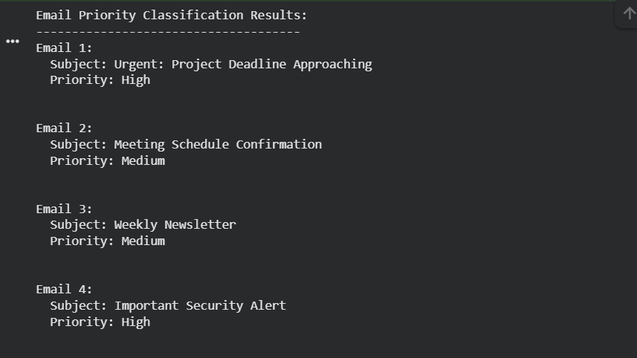
Justification:
The code was generated to fulfill your request to classify email priority into high, medium, and low based on certain keywords. It includes a function classify_email_priority that takes an email subject and body, checks for predefined high and medium priority keywords, and returns the corresponding priority level.
TASK3:
ZERO SHOT PROMPT:
Write a python code for classiying the student queries to admissions, exams, fees and others based on certain keywords. Create 10 student queries inside the code itself and print the classification result for each query. CODE:
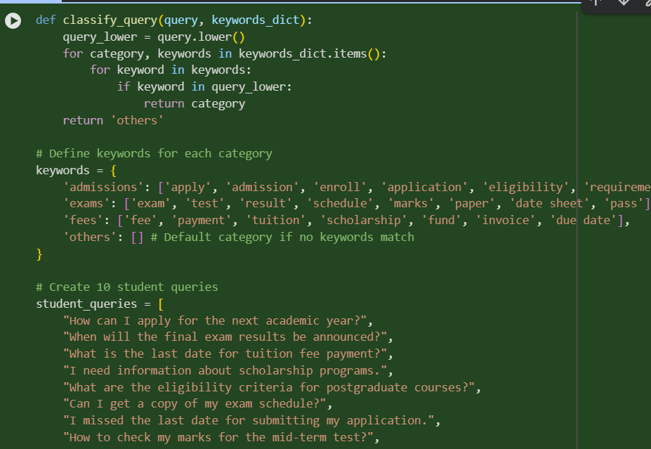
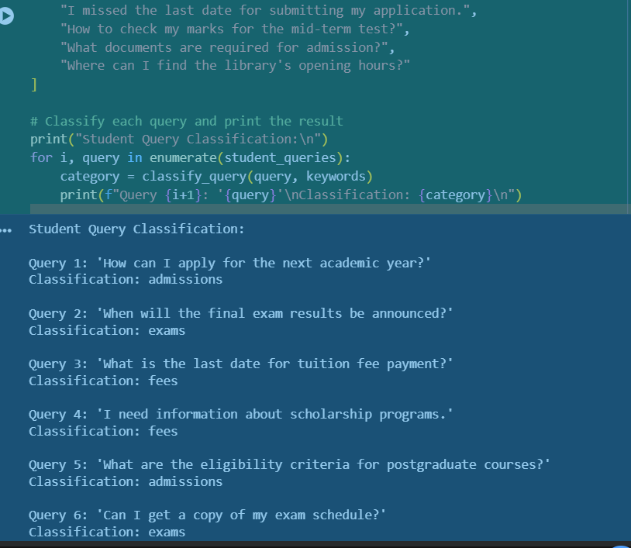
ONE SHOT: Write a python code for classiying the student queries to admissions, exams, fees and others based on certain keywords.create 10 student queries inside the code itself and print the classification reult for each query.Example: I apply for admission to the university?,When are the final exams scheduled for this semester?Now generate python code to display the output for all queries in the same format as above.i want data in code itself not in output. CODE:
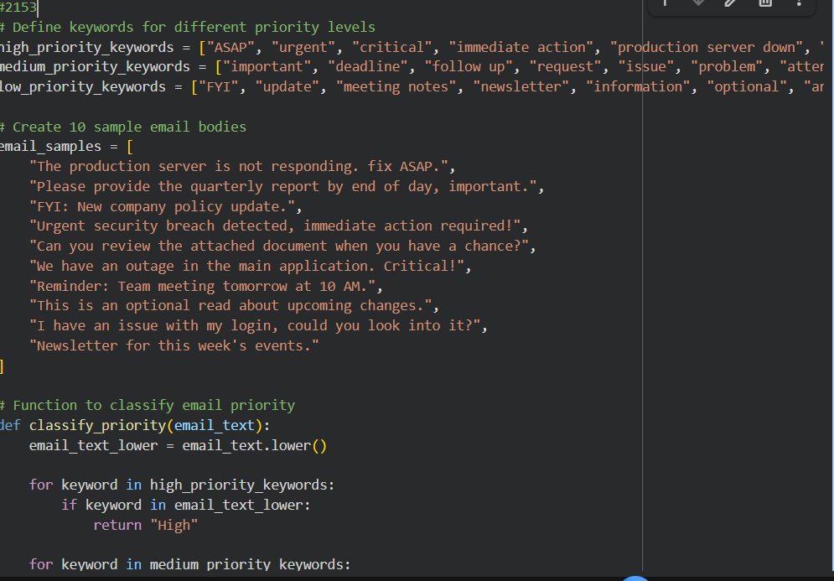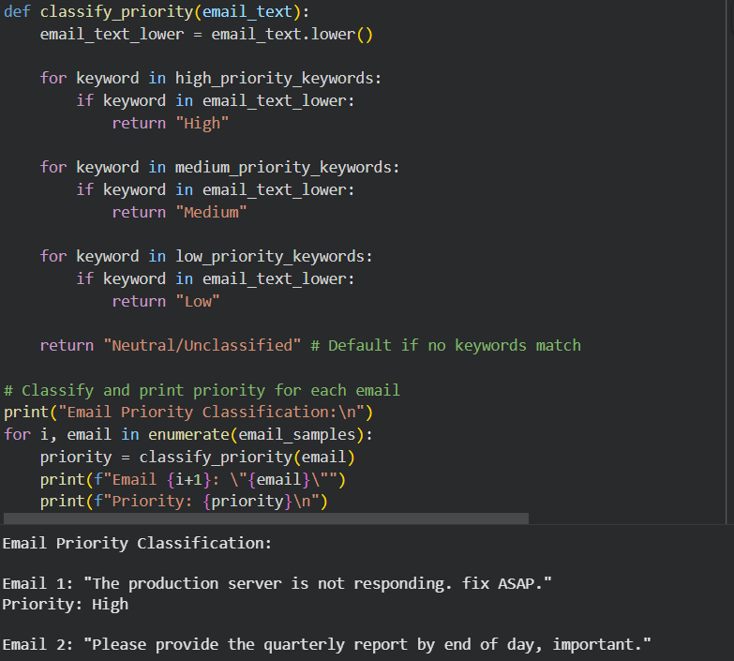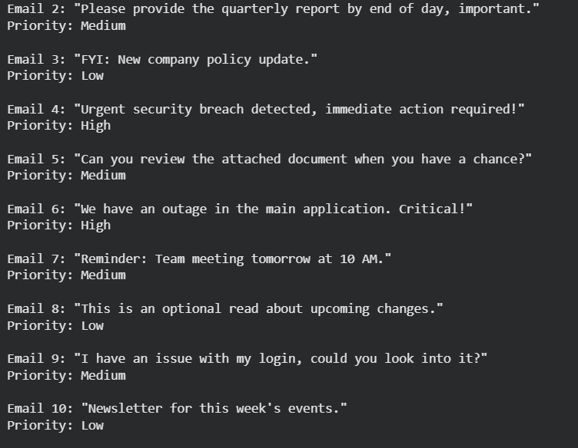
TASK4:
ZERO SHOT: Generate the Python code that identifies whether a user query is Informational, Transactional, Complaint, or Feedback. Create 10 user queries inside the code itself and print the classification result for each query.
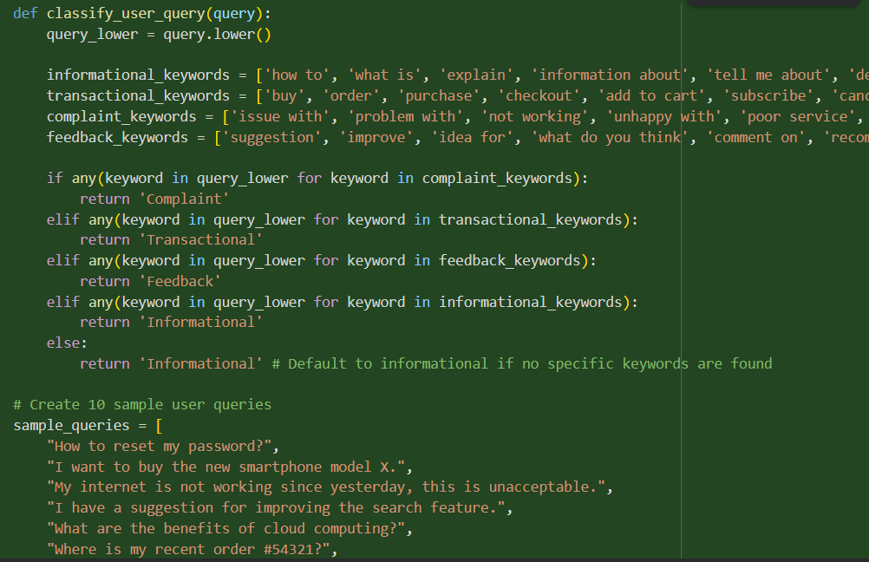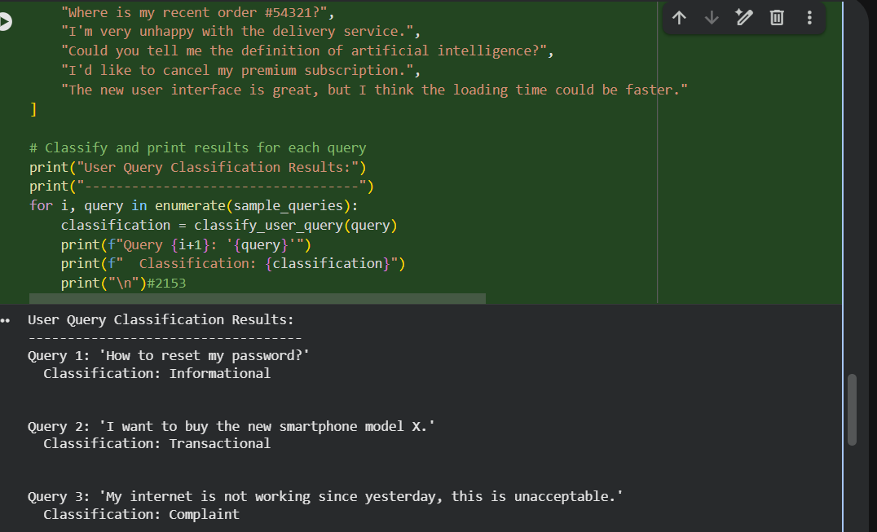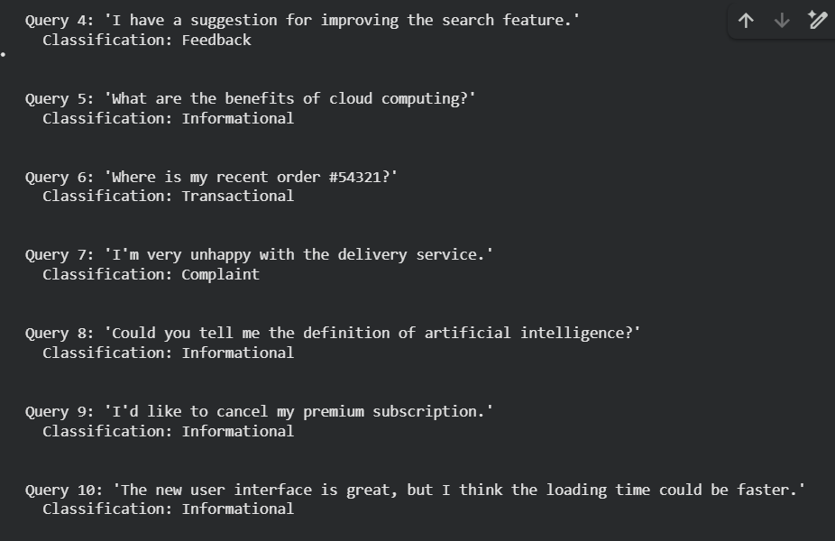
Justification:
It defines a function classify_user_query that takes a query string, converts it to lowercase, and then checks for the presence of specific keywords associated with each category. If a keyword from a category is found, that category is returned. If no specific keywords are matched, it defaults to 'Informational'

